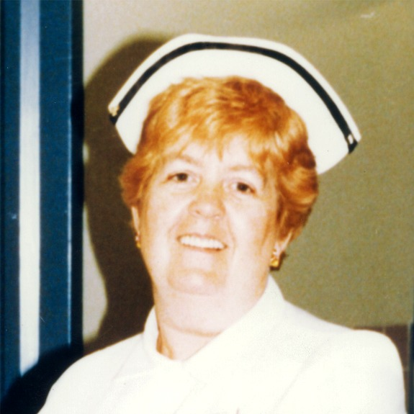

The Lois Fairley
Community Service Award

In recognition of the outstanding contribution nurses make to care for residents of Windsor-Essex.

The Registered Nurses Association of Ontario (RNAO), Windsor Essex Chapter is proud to recognize Registered Practical Nurses, Registered Nurses and Nurse Practitioners during National Nursing Week.

In 500 words or less tell us a story about how a nurse or colleague impacted your life or changed the life of a client/family.

AWARD GUIDELINES
The Annual Lois Fairley Nurse of the Year Community Service Award will recognize a Windsor-Essex nurse who has demonstrated a commitment to serving the community through excellence in delivering nursing care.

Registered Nurse Lois Fairley was a graduate of Grace Hospital in Windsor in 1955, where she served until her retirement in 1993. She worked in a number of departments in the hospital, serving as a head nurse and mentor to students in the nursing programs of the University of Windsor and St. Clair College. As Provincial President of The Ontario Nurses Association, she was an advocate for the nursing profession and for the patients in their care. She also served in a number of roles with the Registered Nurses Association of Ontario including board member. At the hospital, she also led and promoted fundraising efforts to improve patient services. Her greatest satisfaction as an R.N. was the time spent in direct patient care, where she exemplified the best traditions of the nursing profession. Lois passed away in July of 2007, leaving a lasting legacy of love and caring.
Additional information may be found at:
http://en.wikipedia.org/wiki/Lois_Ann_Fairley

NOMINEES (NURSES) SHOULD
- Have proven themselves to be advocates for patients and the nursing profession
- Be committed to the service of patients/clients
- Demonstrate commitment and support for the community of coworkers where the nurse is employed

NOMINATIONS SHOULD BE ACCOMPANIED BY
- A letter from the nominating individual telling a story about how a nurse displays the above listed qualities (500 words or less)
- This completed form

NOMINATION INFORMATION - PLEASE PRINT
NOMINATOR NAME______________________________________

TELEPHONE (H)_____________________(W)__________________

ADDRESS_______________________________________________

CITY_________________ PROV________POSTAL CODE__________

NAME OF THE NURSE NOMINATED
___________________________________
NURSES PLACE OF EMPLOYMENT___________________________
TELEPHONE NUMBER _______________________________

